**Task 1 OUTPUT:**

**1. COPY THE DATA FROM SERVER 1, DB 1, TABLE A TO SERVER 2, DB2, TABLE X**

**Task 2 OUTPUT:**

**2. COPY THE DATA FROM SAME CONTAINER, FOLDER 1 TO FOLDER2**

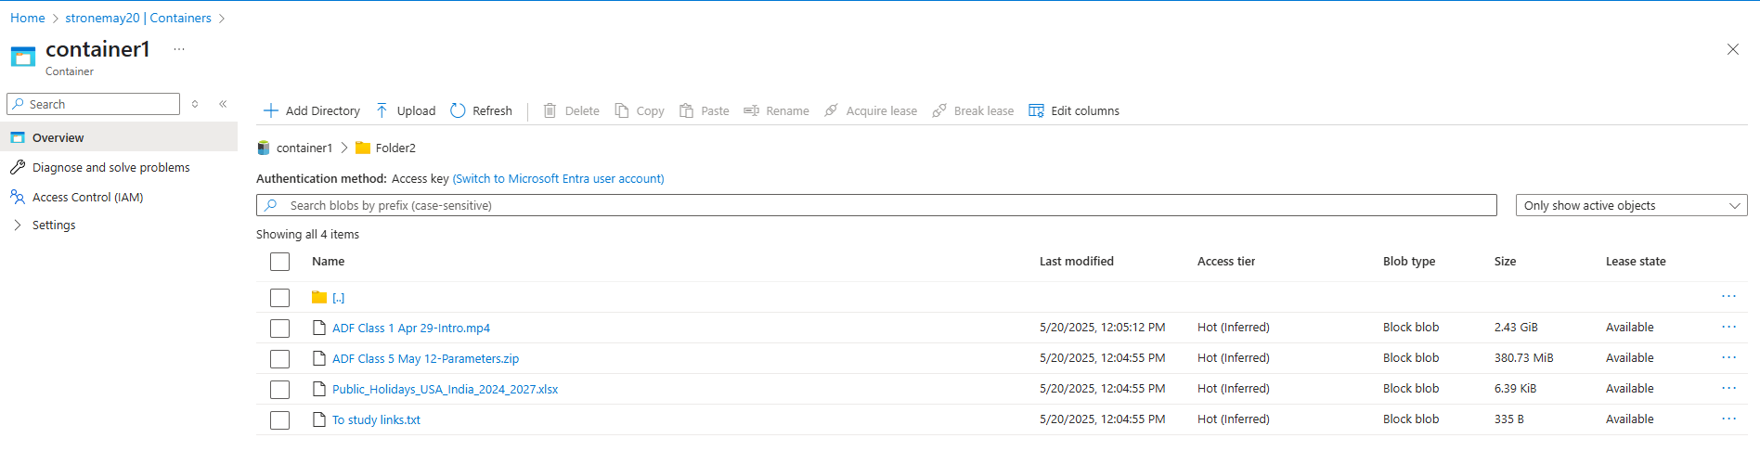

**Task 3 OUTPUT:**

**3. COPY THE DATA FROM CONTAINER1, FOLDER1 TO CONTAINER 2 FOLDER 2**

**Task 4 OUTPUT:**

**4. COPY THE DATA FROM CONTAINER1, FOLDER1, FILE1 TO CONTAINER2, FOLDER2, FILE2**

**Task 5 OUTPUT:**

**5. COPY THE DATA FROM ONE STORAGE ACCOUNT TO ANOTHER STORAGE ACCOUNT**

**Task 6:**

**Delete multiple csv files from source location based on wildcard search**

**Output:**

**Task 7:**

**Delete the file based on Parameter--> while executing you need to give the parameter name**

**Task 8:**

